SUNDAY OF MEATFARE — Tone 3. Sunday of the Last Judgment. Hieromartyr Polycarp, Bishop of Smyrna (167). Ven. Polycarp of Briansk (1620-1621). Ven. John, Antiochus, Antoninus, Moses, Zebinas, Polychronius, Moses, and Damian, Ascetics, of the Syrian deserts (5th c.). Ven. Alexander, founder of the Monastery of the “Unsleeping Ones” (ca. 430). Ven. Damian of Esphigmenou (Mt. Athos—1280). Monastic Martyr Damian of Philotheou (1568).
1 Corinthians 8:8-9:2 Matthew 25:31-46
It is love again that constitutes the theme of "Meat-Fare Sunday." The Gospel lesson for the day is Christ's Parable of the Last Judgment. When Christ comes to judge us, what will be the criterion of His judgment? The Parable answers: love--not a mere humanitarian concern for abstract justice and the anonymous "poor," but concrete and personal love for the human person, any human person, that God makes me encounter in my life...
Christian love is the "possible impossibility" to see Christ in another man, whoever he is, and whom God, in His eternal and mysterious plan, has decided to introduce into my life, be it only for a few moments, not as an occasion for a "good cheer" or an exercise in philanthropy, but as the beginning of an eternal companionship in God Himself. For, indeed, what is love if not that mysterious power which transcends the accidental and the external in the "other"--his physical appearance, social rank, ethnic origin, intellectual capacity--and reaches the soul, the unique and uniquely personal "root" of a human being, truly the part of God in him? If God loves every man it is because He alone knows the priceless and absolutely unique treasure, the "soul" or "person" He gave every man. Christian love then is the participation in that divine knowledge and the gift of that divine love. There is no "impersonal" love because love is the wonderful discovery of the "person" in "man," of the personal and unique in the common and general. It is the discovery in each man of that which is "lovable" in him, of that which is from God.
The Parable of the Last Judgment is about Christian love. Not all of us are called to work for "humanity", yet each one of us has received the gift and the grace of Christ's love. We know that all men ultimately need this personal love--the recognition in them of their unique soul in which the beauty of the whole creation is reflected in a unique way. We also know that men are in prison and are sick and thirsty and hungry because that personal love has been denied them. And, finally, we know that however narrow and limited the framework of our personal existence, each one of us has been made responsible for a tiny part of the Kingdom of God, made responsibly by that very gift of Christ's love. Thus, on whether or not we have accepted this responsibility, on whether we have loved or refused to love, shall we be judged. For "in as much as you have done it unto one of the least of these My brethren, you have done it unto Me…"
-- by Fr. Alexander Schmemann, an excerpt from Great Lent

SCHEDULE

Sun., Feb. 23……………………..9:00 am Choir Rehearsal
9:30 am 3rd Hour
9:45 am General Confession
10:00 am Divine Liturgy
Sunday of the Last Judgment

Sat., Feb. 29………………………5:30 pm Panikhida
6:00 pm Great Vespers
7:00 pm Choir Rehearsal

Sun., Mar. 1………………………9:30 am 3rd Hour
9:45 am St Xenia Prayers
10:00 am Divine Liturgy
Rite of Forgiveness
Forgiveness Sunday

Welcome to all our visitors
Please join us for Coffee Hour

COFFEE HOUR
Many thanks to Sonia Blazo for hosting Coffee Hour today. We are in need of more people to host Coffee Hour, which is an important ministry to our parish. Please sign-up in Founders Hall.

CONDOLENCES to the Lyzak family on the passing of +Boris.
Memory Eternal!

SUNDAY of ORTHODOXY: You are invited to sing at Vespers on
7:30 pm and March 8th @ 5 pm.
See the flyer on the bulletin board for more information.

Donation for Homeless Solutions in Morristown
Today’s offering basket is for Homeless Solutions. Thank you for your support!

Teen Retreat
The Great Fast is quickly approaching which means our Annual Lenten Teen Retreat is, as well! Please mark your calendars- AND REGISTER- for the weekend event being held April 3-5, 2020 at a new venue, Greenkill YMCA Retreat Center in Huguenot, New York, conveniently located on the borders of New York State, New Jersey, and Eastern Pennsylvania near Port Jervis!

Our parish website (www.holytrinityrandolph.com) is the best place to find the current, updated church calendar for the month. The whole website is a good place to explore, and, if you use a Google calendar for your own events, you can link the church calendar to it. To see all the events on a day, just click on the day. The website also has the current Prayer List — people who need our prayers for health or other good intentions. Use the password holytrinity to enter that area of the website. If you have questions, please see a Council member.

Please remember to support the following: The Interfaith Food Pantry (you can drop off food goods in the basket in the Narthex), Shoprite Gift Cards, and our Amazon Smile HTOC link: www.amazon.com/?tag=holytrinorthc-20

Sunday of Meatfare of the Last Judgment
Troparion — Tone 1
When You, O God, shall come to earth with glory, / all things shall tremble / and the river of fire shall flow before Your judgment seat; / the books shall be opened and the hidden things disclosed! / Then deliver me from the unquenchable fire, / and make me worthy to stand at Your right hand, righteous Judge!

“If you want to grab God’s attention so He’ll hear you during prayer, turn the dial to humility, for God always works in this frequency, then humbly ask for His mercy.” + St. Paisios of Mount Athos

“The devil is afraid of us when we pray and make sacrifices. He is also afraid when we are humble and good. He is especially afraid when we love Jesus very much. He runs away when we make the Sign of the Cross.” + St. Anthony the Great

Holy Trinity Orthodox Church
Offering the Fullness of the Christian Faith
Orthodox Church in America
Diocese of New York and New Jersey
PO Box 630, Ironia, NJ 07845: 120 Dover-Chester Road, Randolph, NJ 07869
973-366-8360 / www.holytrinityrandolph.com

Very Rev. David R. Fox, Rector
(c) 201-841-7590 – fatherdavid@holytrinityrandolph.com
Very Rev. George Hasenecz, Attached – Carol Wetmore, Choir Director

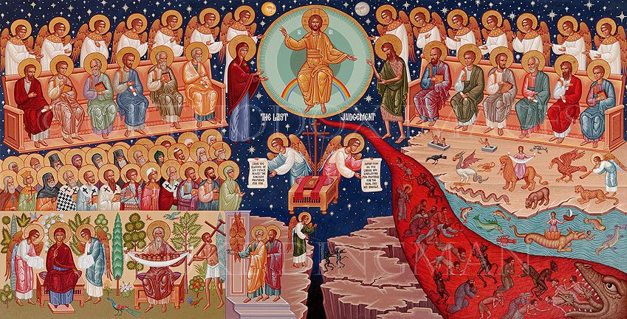

Sunday of the Last Judgment – Meatfare Sunday

February 23, 2020

